Assignment 1

1. Launch an EC2 instance with the Amazon Linux AMI.

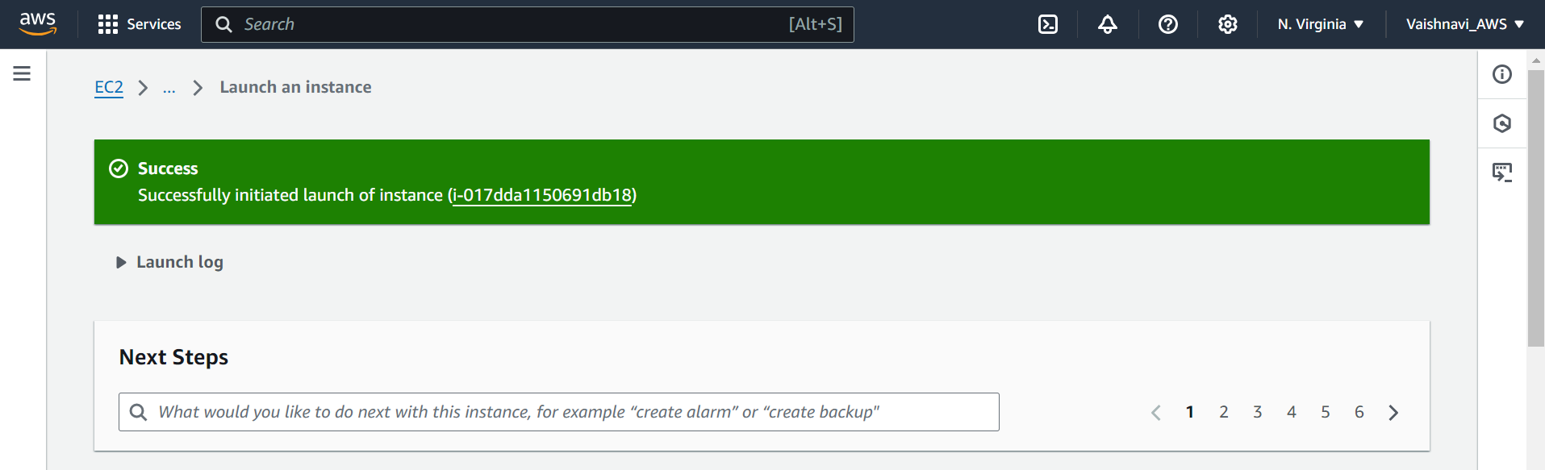

1. Select an instance type (t2.micro) and configure it for public access.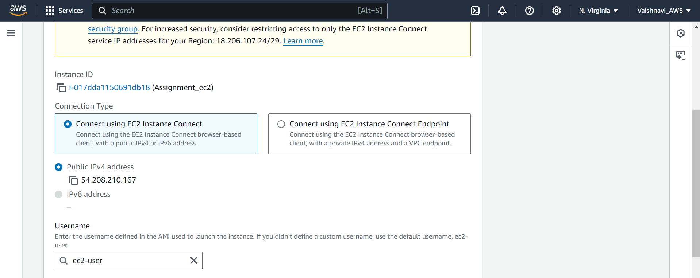
2. Document the instance ID and public IP address.

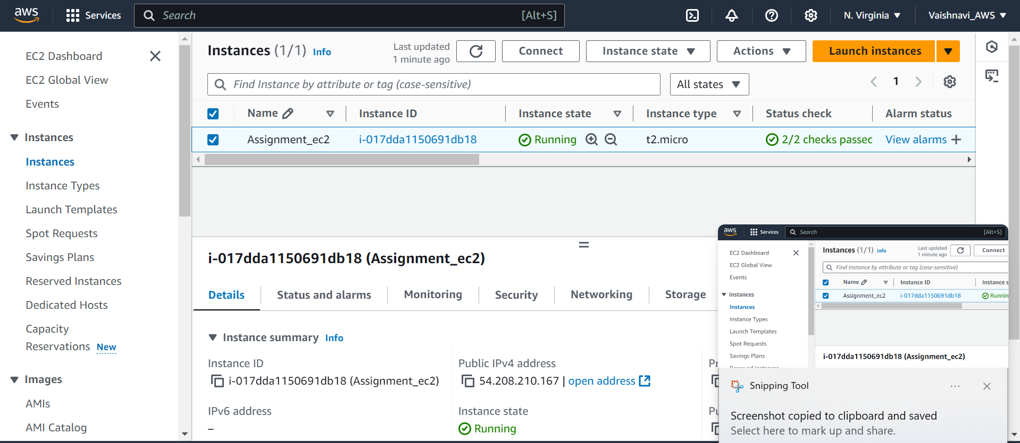

4. Create a security group that allows SSH (port 22) and HTTP (port 80).

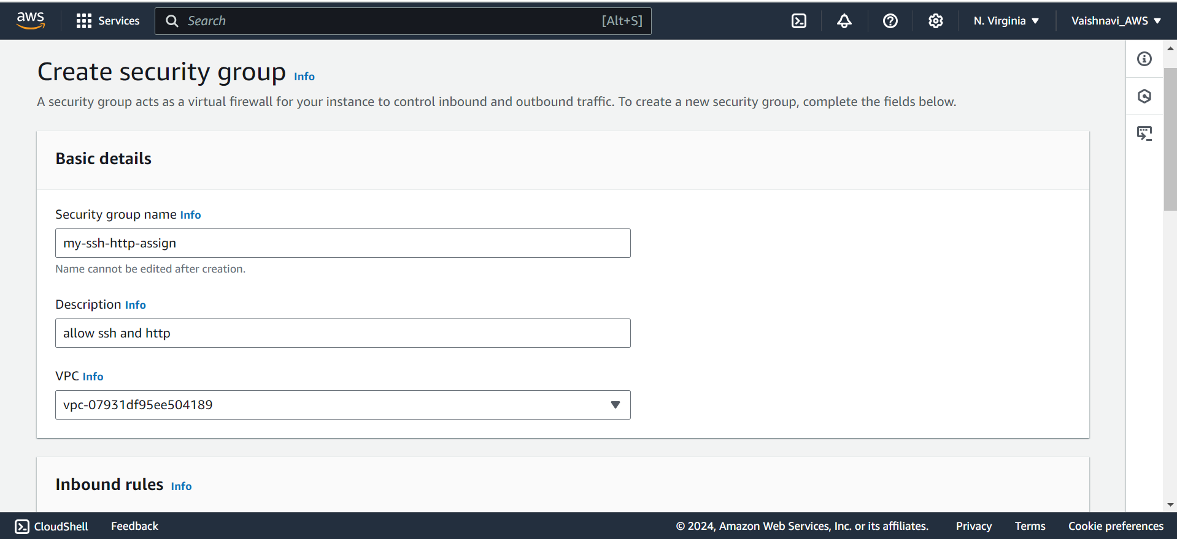

1. Attach the security group to your EC2 instance.

ASSIGNMENT 2:

1. Create three IAM users with different permissions (e.g., Admin, Read-Only, S3 Access).

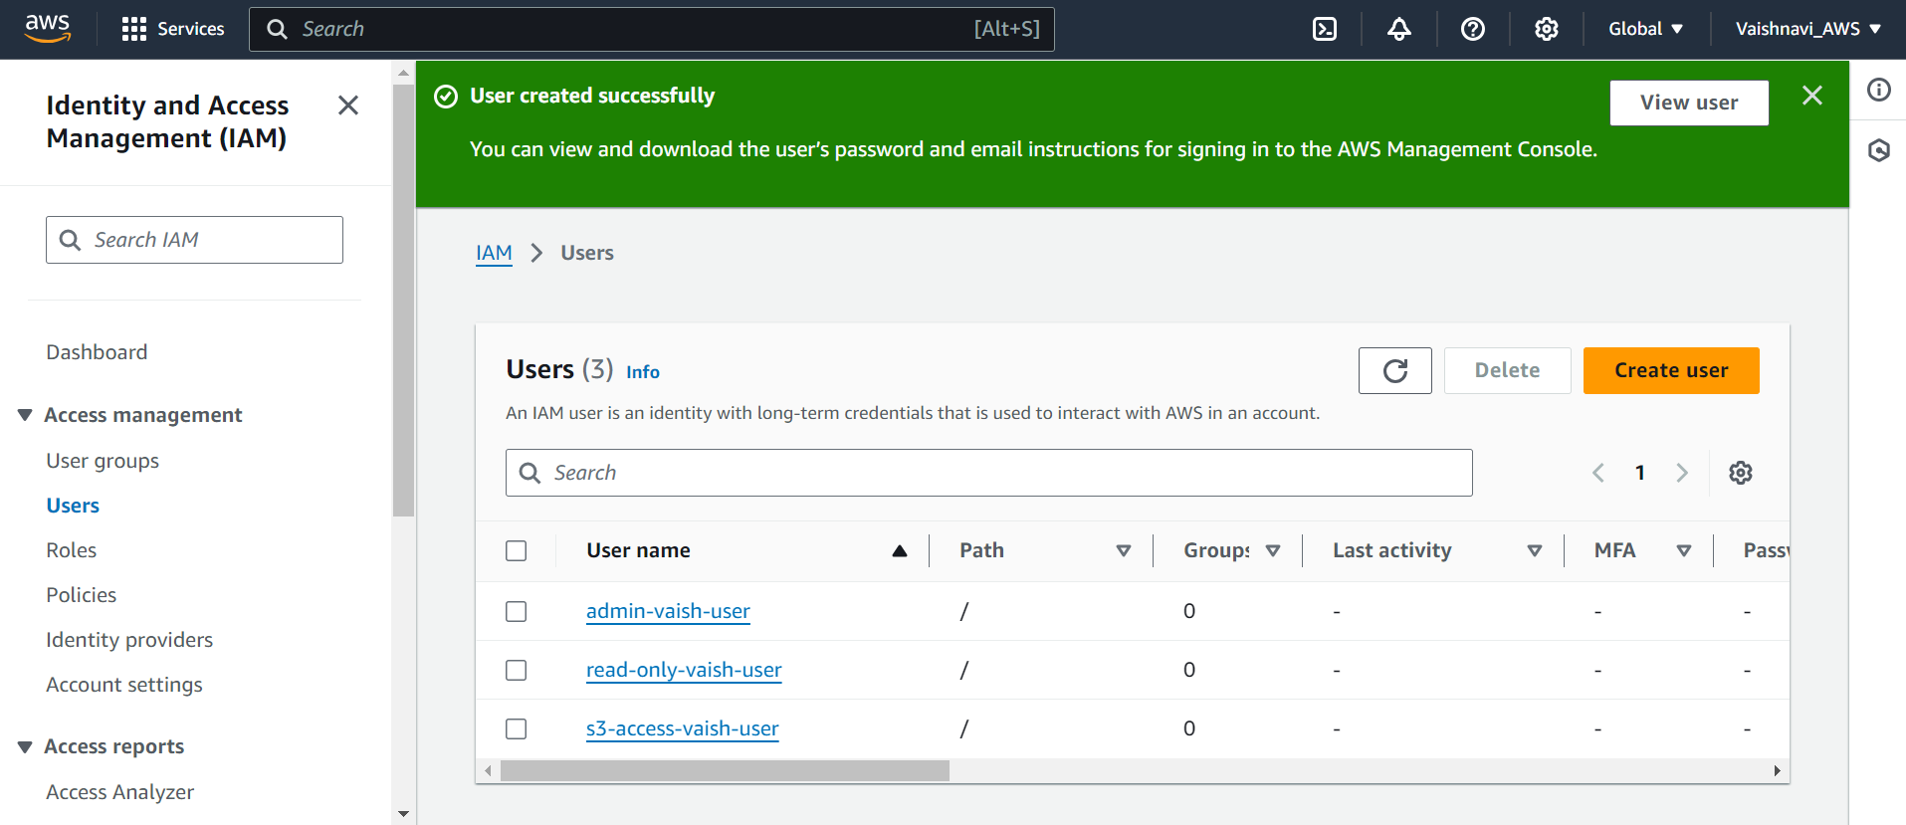

2. Provide details of the policies attached to each user.

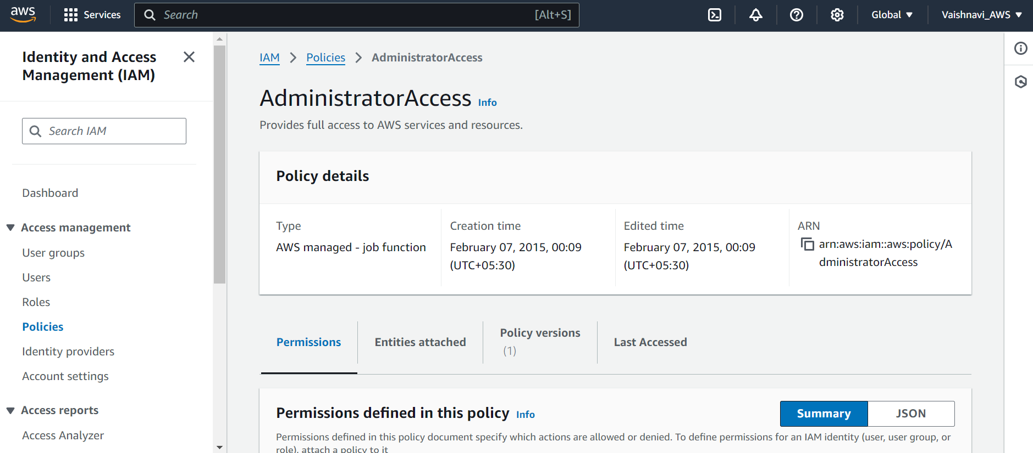

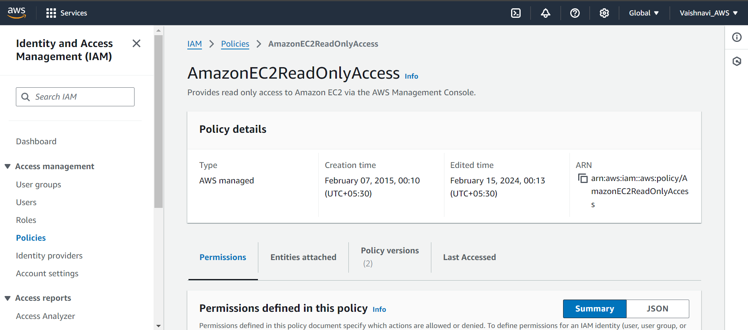

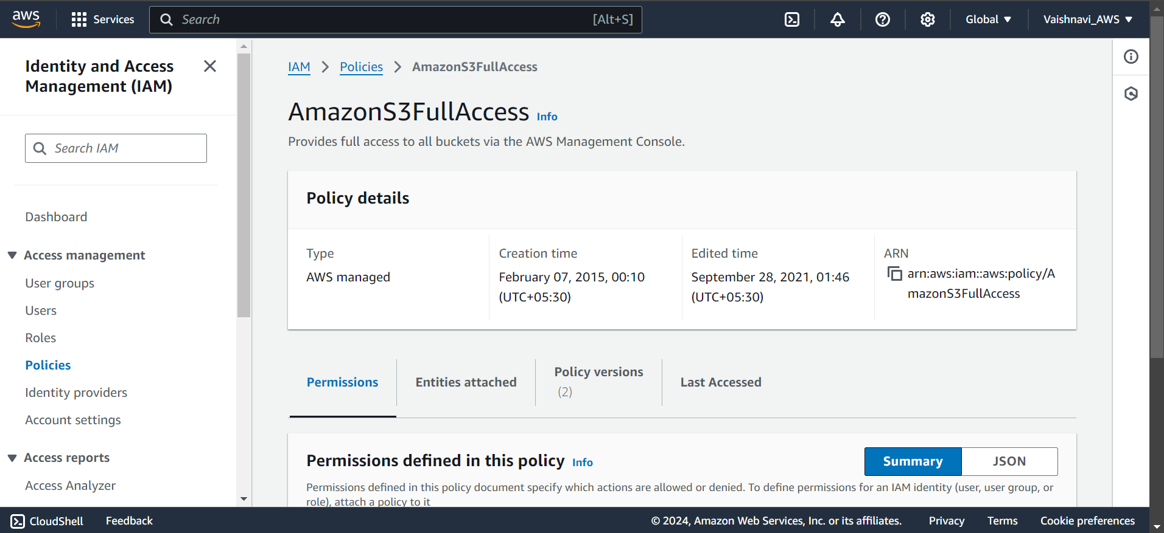

3. Enable MFA for one of the IAM users.

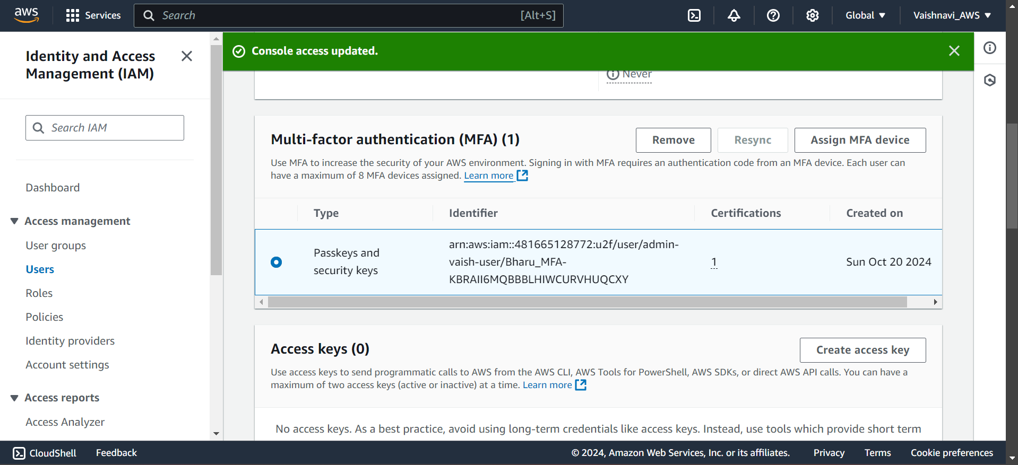

Create an IAM role for EC2 instances that allows access to S3 buckets.

